Linux Commands Part II

1.

2.

3.

4.

5.

\***awk** is much easier to use for cutting some of the columns. With **grep**, I would have to use some combination of other commands to gain the result.

6.



7.

8.

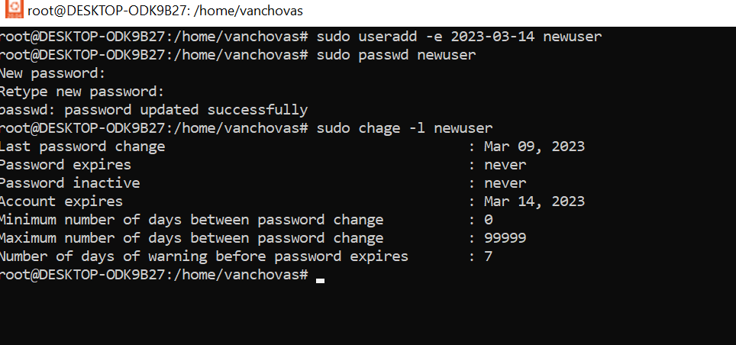

9.

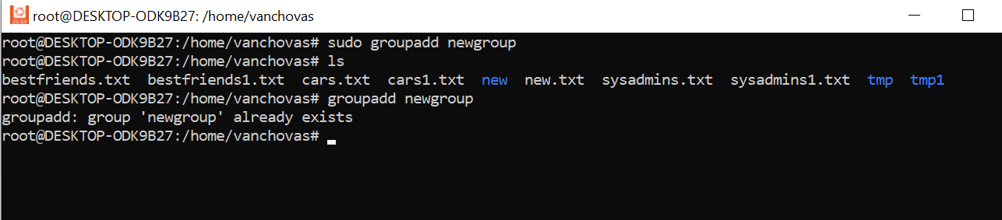

10.

11.

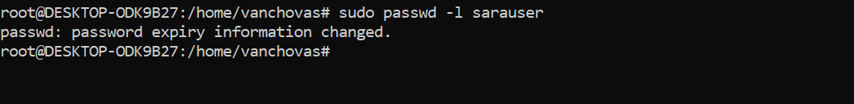

12.

*I don’t have that tcsh shell. But I would use command:

*It couldn’t locate the package, so I couldn’t change the shell but this is the command.

13,14,15

*Since all of the directories have “execute” permissions for user, group and other so do the directories in my home directory.

16, 17

*The color id green, because it has changed permissions.

18.

19. *The third column shows us the owner, which was root.(This is updated homwork, so that is why the owner is alredy changed).

20.

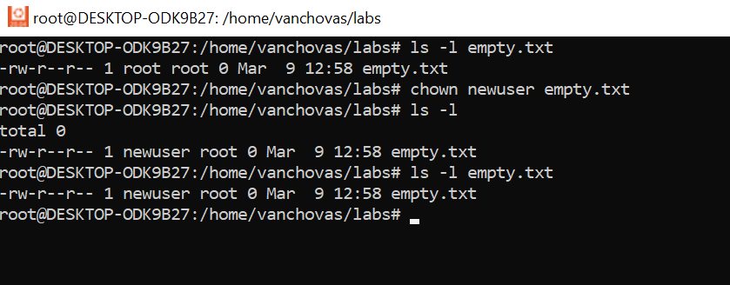

21.

22.

23.

*First had to change the group to group1 (that is shown in the 4th column of the ls -l) and than I change that to one of my users.

24.

